Question 1: Find out the mail servers of the following domain :

1. Ibm.com
2. Wipro.com
3. Ibm.com:

Finding mail server in Window OS:

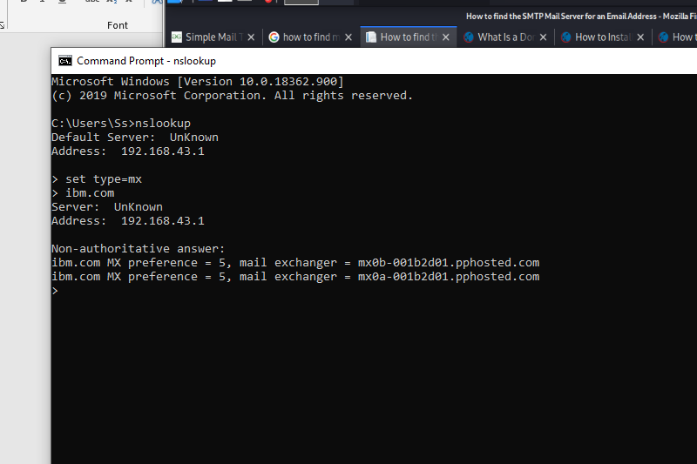

Finding mail server in Window Debian kali linux:

